**SET UP FLUTTER**

**Prebared by: Charles Kurt Caber**

# Steps:

The Initial steps are:

* Download the Android Studio.
* Next, we need to download Git.
* The Next Step is to install [flutter](https://flutter.dev/docs/get-started/install/windows).

# Flutter Installation:

For Flutter Installation, first you need to go to your **C://** drive and create a folder called **“src”.**

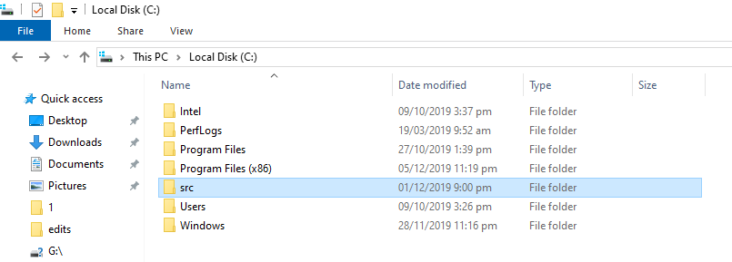

After creating a folder, just go into that folder and run the below command from Git Bash here.

***git clone -b stable***[***https://github.com/flutter/flutter.git***](https://github.com/flutter/flutter.git)

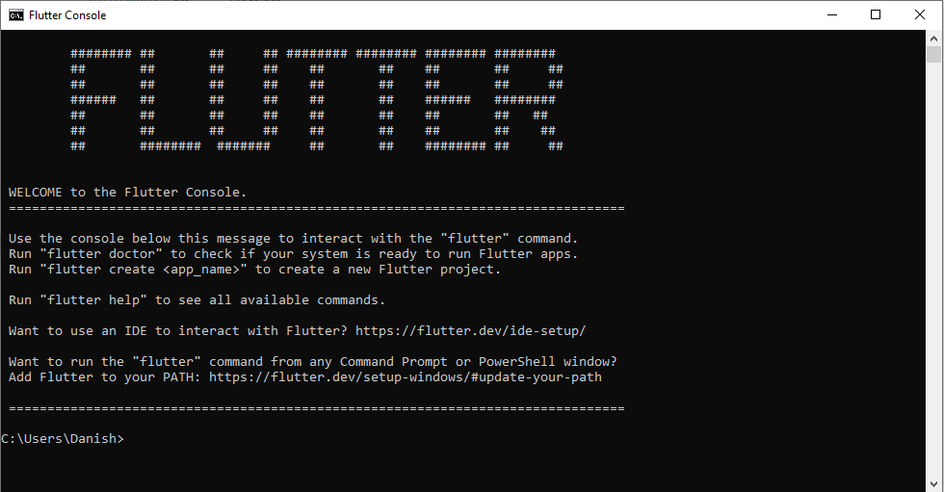It will download the flutter repository from Github. And After the installation you will need to go to the flutter folder inside the src folder, and run flutter console you will see like below screenshot:

After that you will need to write a flutter command in that console to Install the flutter SDK:

*Type : flutter doctor*

Now you run for the first time it will take a couple of minutes to install. After successfully installation just run

*Type : flutter — version*

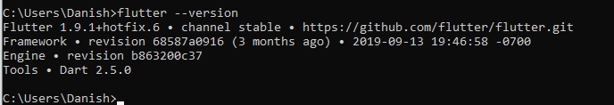You will see the version

# Install Flutter Plugin to Android Studio:

After successful installation of flutter, now we need to install a flutter plugin in Android studio for that you need to go to Settings->Plugins-> Search Flutter and install the plugin and restart Android Studio, like the below screenshot.

Android Studio Plugin Installation

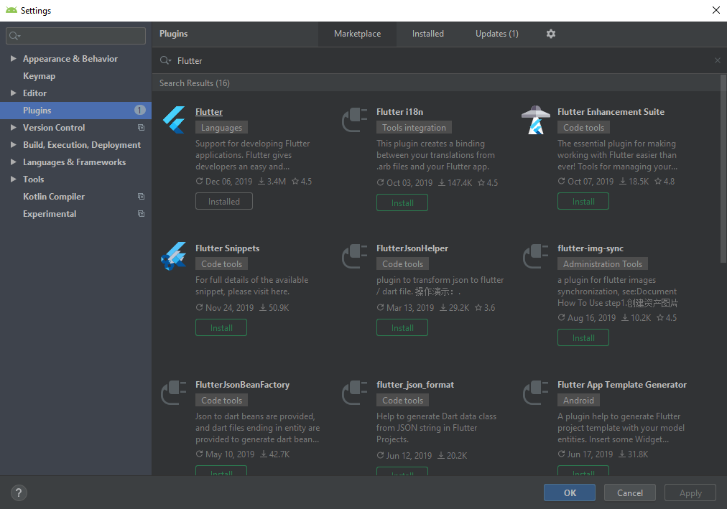Now you will create a flutter project in Android Studio like the below screenshot.

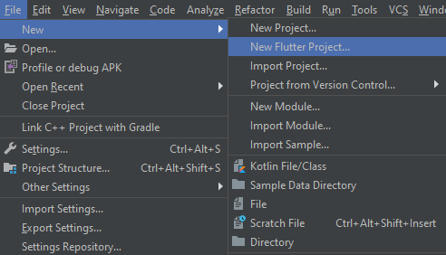

Create or Import a flutter project

Source : <https://medium.com/flutterpub/flutter-installation-setup-with-android-studio-326dea65f609>

<https://enappd.com/blog/setup-flutter-in-windows-and-mac/36/>

Note * if the instruction is not cleared I prepared a video by Angela Yu on youtube on how to set up flutter environment on windows.

Link : <https://www.youtube.com/watch?v=Z2ugnpCQuyw&list=PLSzsOkUDsvdtl3Pw48-R8lcK2oYkk40cm&index=4>